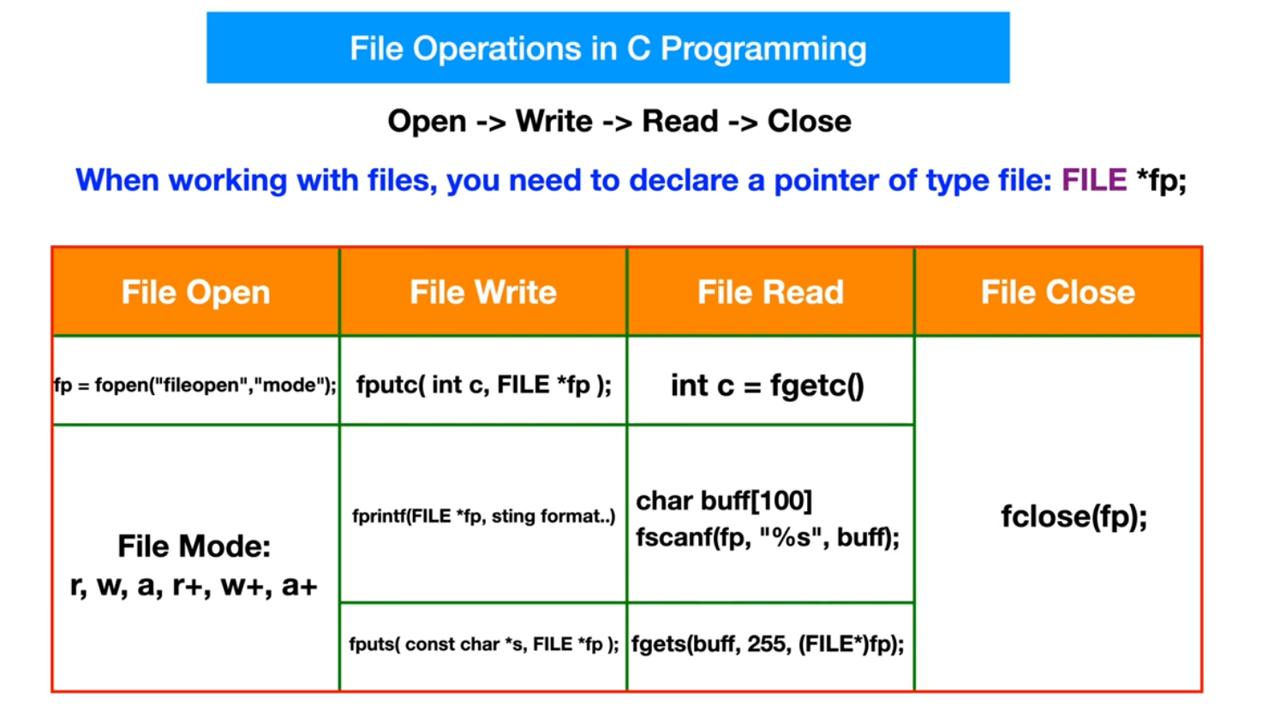

|  |  |
| --- | --- |
| Scanf Functions | Printf Functions |
| fgetc(to scan character type data) | fputc(to printf character type data) |
| fscanf(to scan normal type data) | fputs(to printf string type data) |
|  | fprintf(to printf normal type data) |

|  |  |
| --- | --- |
| fopen(to open Or create a file) | fclose(to close a file) |

1. r - open a file in read mode.
2. w - opens or create a text file in write mode.
3. a - opens a file in append mode.
4. r+ - opens a file in both read and write mode.
5. a+ - opens a file in both read and write mode.
6. w+ - opens a file in both read and write mode.